# Exercises: Razor Engine

Problems for exercises and homework for the [“C# MVC Frameworks - ASP.NET” course @ SoftUni](https://softuni.bg/trainings/1537/csharp-mvc-frameworks-asp-net-march-2017).

## Navbar

In the Car Dealer System add a navigational bar menu to the website with the following structure

* **Customers** - customers/all/
  + **Ascending –** customer/all/ascending
  + **Descending –** customers/all/descending
* **Sales**
  + **All** – /sales
  + **Discounted** - sales/discounted
* **Cars** - cars/all
* **Suppliers**
  + **Local –** suppliers/local
  + **Importers –** suppliers/importers

Use the Razor helper methods.

## Hyperlinks

In the Car Dealer’s System modify all hyperlinks to be created by the Razor’s helper methods. Including all hyperlinks that lead to pages of cars, customers and sales by provided ID for example.

## Add Cars Form

Using the Razor’s helper methods recreate the form for adding cars in the Car Dealer’s System.

## Add Parts Form

Using the Razor’s helper methods recreate the forms for adding and deleting parts in the Car Dealer’s System.

## Sales Form

Using the Razor’s helper methods recreate the forms for adding a new sale in the Car Dealer’s System.

## Suppliers Form

Using the Razor’s helper methods recreate the form of adding suppliers in the Car Dealer’s System.

## Users Info

Create a sample collection of **Users** (name, age, email, is subscribed to newsletters). **Visualize this collection** on some page in a table.

### Example

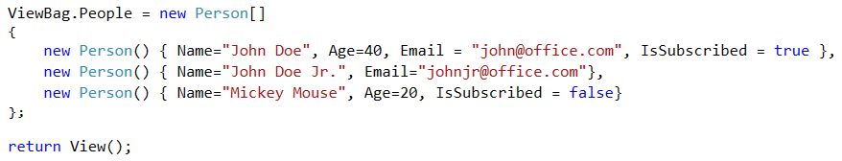

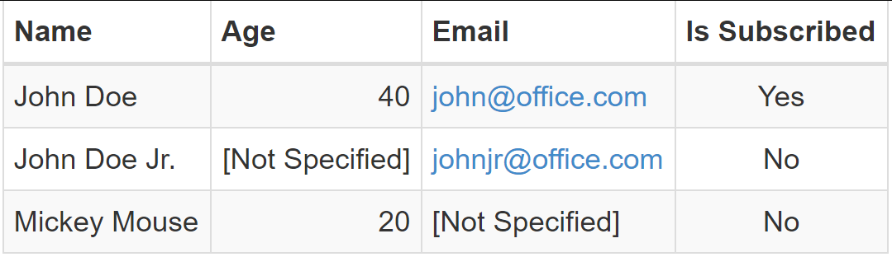

## Image Helper

Create **custom Helper extension** to allow you to **add images** easily to a web page, by providing **URL** or **path** to the image and **alternative text, width** and **height** as optional parameters.

### Examples

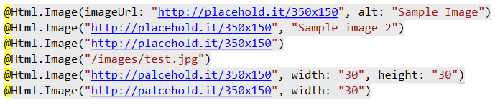

## YouTube Embedder

Create custom helper extension that allow you to easily embed videos from YouTube by just providing the ID of the video and as optional parameters width and height. The default width is 560 and default height is 315. You can use the following HTML template to embed video on a page

<iframe width="{width}" height="{height}"  
 src="https://www.youtube.com/embed/{videoId}" frameborder="0"  
 allowfullscreen></iframe>

### Examples

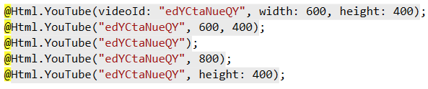

## Table Helper

Create a custom Helper that allow you easily print a simple table by providing some **collection of objects**. The names of the **properties** in the object should be used as **table headers**. Each **row** of the table should show the data for a **single object** of the collection. Also, **none or several CSS classes** should be able to be applied to style the table.

### Examples

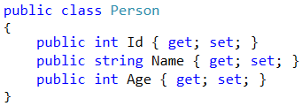

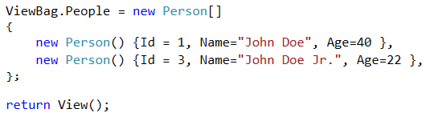

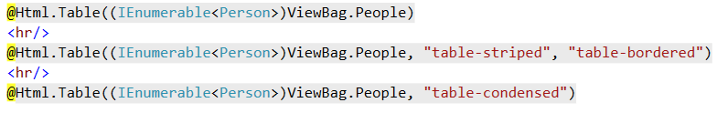

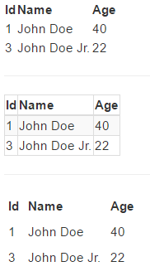

## Camera Bazaar

You need to create an **online store** for shop selling digital cameras. All visitors of the store should have access to the **list of cameras** and could see their **details**. All visitors could **register** into the store. The registered users can **add, edit** and **delete** cameras. Each user can **modify** only those cameras that are **added by him**.

The requirements for the **models** are:

* **User**
  + **Username** – must be between **4** and **20** symbols long and must contain **only letters**. Casing **does not** matter.
  + **Email** – must be a **valid email address**
  + **Password** – must be at least **3 symbols** long and can contain only **lowercase letters** and **digits**
  + **Phone** – must start with “**+**” sign followed by **10 to 12 digits**
* **Camera**
  + **Make** – makes can be only **Canon**, **Nikon**, **Penta** or **Sony**
  + **Model** – can contain **only uppercase letters**, **digits** and **dash** (“**-**“). Cannot be empty
  + **Price** – floating point number with precision to **2 digits** **after** floating point
  + **Quantity** – integer number in range **0 – 100**
  + **Min shutter speed** – integer number in range **1 to 30** (seconds)
  + **Max shutter speed** – integer number in range **2000 to 8000** (fraction of a second)
  + **Min ISO** – can be **50 or 100**
  + **Max ISO** – integer number in range **200 to 409600** and must be **dividable by 100**
  + **Is Full Frame** – **yes** or **no**
  + **Video Resolution** – described with text **no longer than 15 symbols**
  + **Light Metering** – can be **spot**, **center-weighted** and **evaluative**
  + **Description** – details for the camera with no more than **6000 symbols**
  + **Image URL** – must start with **http://** or **https://**

In each form that **add** or **edit data** if there is a mistake anywhere **notify the user** and provide him information **what exactly is the mistake** and why some data cannot be accepted.

Each **user** should have **profile page** that contains information about **him, list of all his cameras** and summarized count of in stock or out of stock cameras. Profile pages should be accessible **only by registered users**. Each user can **change** his **email,** **phone** or **password**.

Each **camera** should have page where **all details** about it can be seen as well as **link** to the profile to the user who added it.

On the **list of cameras**, the visitors should be able to see clearly whether the **camera is** **in stock or not**. For example, if it in stock add green text “IN STOCK” otherwise red text “OUT OF STOCK”.

